A Binary Search Tree (BST)

## Assignment

Explore BST: <https://visualgo.net/en/bst>

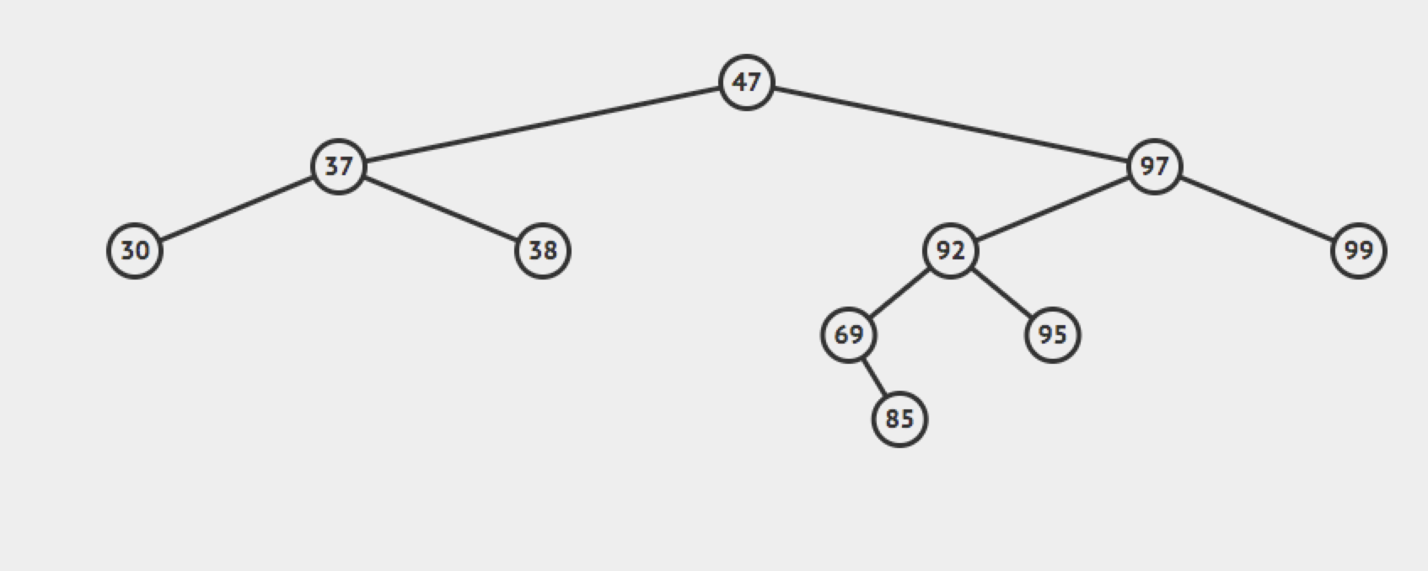

Solution:

<https://replit.com/@rohitbhardwaj/Binary-Tree-Problems#BinarySearchTree.java>

